**Name:** Files\\Grey Literature\\Case Study\\OnwardMobility

¶1: **OnwardMobility Is Shutting Down Without Releasing a Single Product**

¶2: **Losing the BlackBerry license seems to have sealed the company's fate.**

**¶3:**

¶4: [](https://www.pcmag.com/authors/nathaniel-mott)

[¶5:](https://www.pcmag.com/authors/nathaniel-mott) By [Nathaniel Mott](https://www.pcmag.com/authors/nathaniel-mott)

¶6: February 20, 2022

¶7:

¶8: 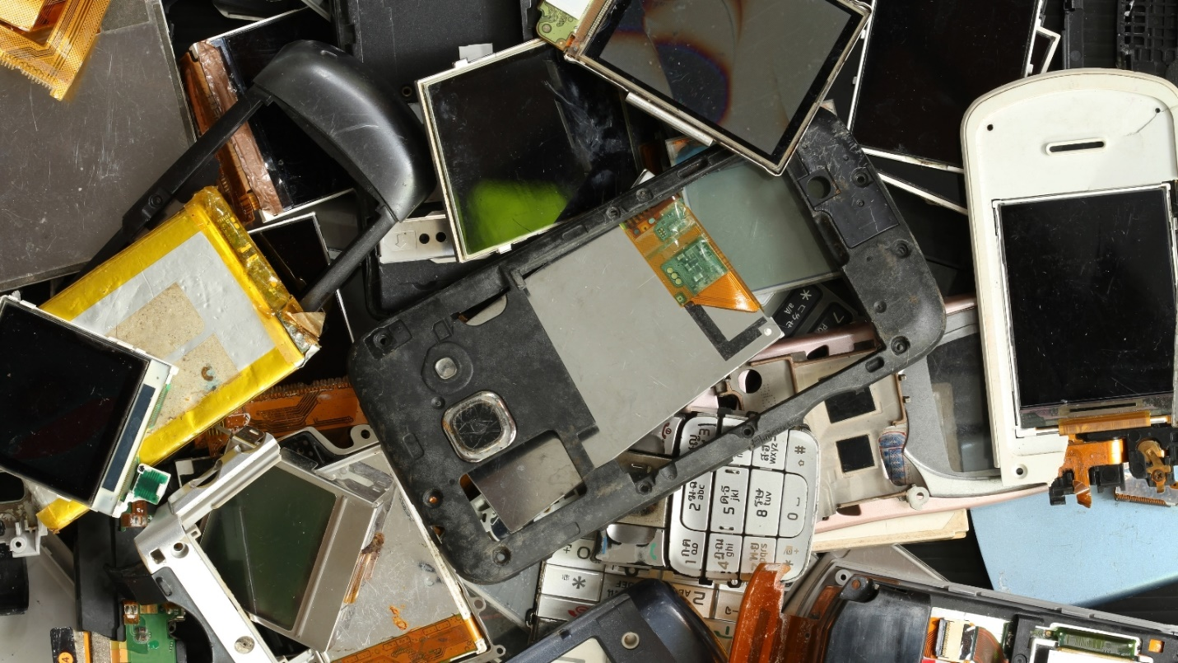(Winai_Tepsuttinun / Getty Images)

¶9: OnwardMobility has confirmed that it's shutting down now that it can't use the BlackBerry name for the "ultra-secure smartphone with a physical keyboard" it expected to release in 2021.

¶10: "Please know that this was not a decision that we made lightly or in haste," the company [says](https://www.onwardmobility.com/) in a farewell letter that has replaced the entirety of its website's content. "We share your disappointment in this news and assure you this is not the outcome we worked and hoped for."

¶11: It almost would've been stranger for OnwardMobility to move forward [with its smartphone](https://www.pcmag.com/news/new-blackberry-with-keyboard-coming-in-2021) than to throw in the towel. The company made [nary a peep](https://www.pcmag.com/news/onwardmobility-stays-mum-on-new-blackberry) about its plans throughout 2021, and despite promises to offer more details about the device throughout January, it remained silent until it posted the farewell letter.

¶12: Android Police also [reported](https://www.androidpolice.com/the-5g-blackberry-is-dead/) earlier this month that OnwardMobility planned to scrap its smartphone after [losing the license](https://www.pcmag.com/news/onwardmobility-reportedly-loses-blackberry-license) to the BlackBerry brand. (Supposedly because BlackBerry CEO John Chen simply doesn't want the brand to be associated with phones anymore.)

¶13: OnwardMobility says in the farewell letter that it's "incredibly grateful to the team of seasoned professionals who worked tirelessly on this project and to each and every one of our loyal fans and partners who have supported us throughout this journey," short as it was.